**Mobile App Interface Design**

**Proposed Design #1:**

Primary color: #6cd695

To be used as backgrounds for headers and buttons.

Font color: #205272

To be used for most text. When there is a block of green background with a header, use this. Use pure white for text below the header in the same block.

|  |
| --- |
| **This is a Header**  This is a description of what this page is. |
|

* All pages of the app should have a Header with a green background at the top.
* Not all pages need a description of what they are for.
* Headers should not have periods.
* All sentences in a description should have periods.
* Words on buttons/next to buttons should not have periods.
* Buttons should have bold text.
* Buttons should not have borders.
* Buttons should stretch across the width of the phone.
* Buttons should have a drop shadow.

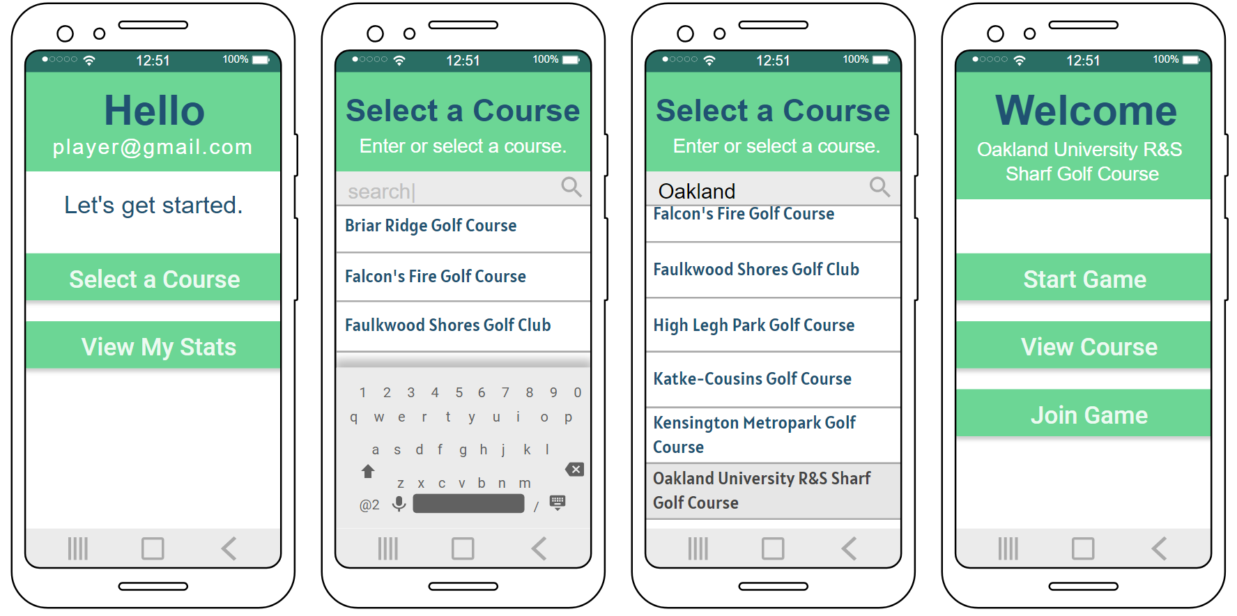

**Proposed Design #2:**

Primary color: #92d36e

To be used as backgrounds for headers.

Font color: #243e16

To be used for most text. When there is a block of green background with a header, use this. Use pure white for text below the header in the same block.

Button color: #aedd94

To be used for buttons.

|  |
| --- |
| **This is a Header**  This is a description of what this page is. |
|

* All pages of the app should have a Header with a green background at the top.
* All pages need a description of what they are for.
* Headers should not have periods.
* All sentences in a description should have periods.
* Words on buttons/next to buttons should not have periods.
* Buttons should have bold text.
* Buttons should not have borders.
* Buttons should have a drop shadow.
* Variant #1: Buttons should stretch across the width of the screen.
* Variant #2: Buttons should be centered and fit in the middle of the screen.

Variant #1:

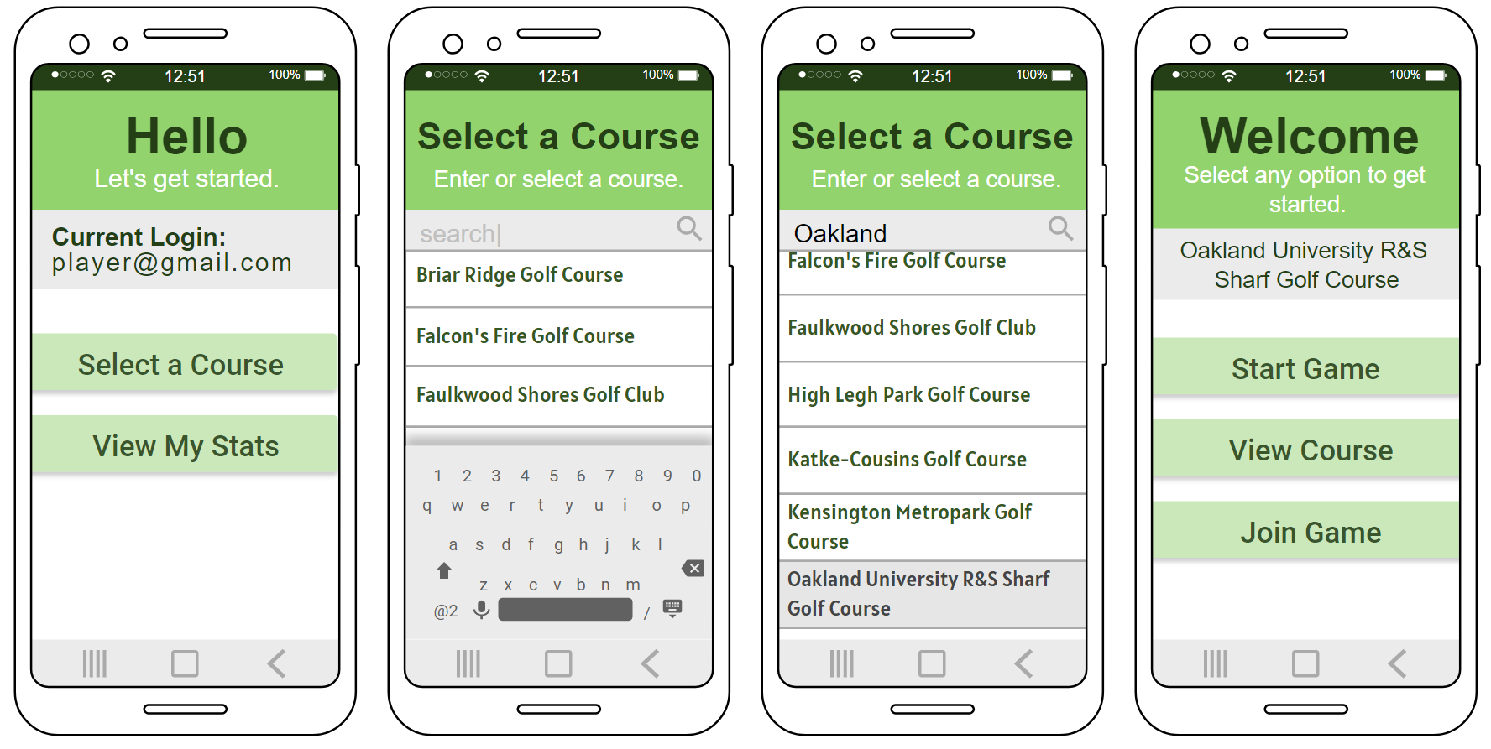

Variant #2: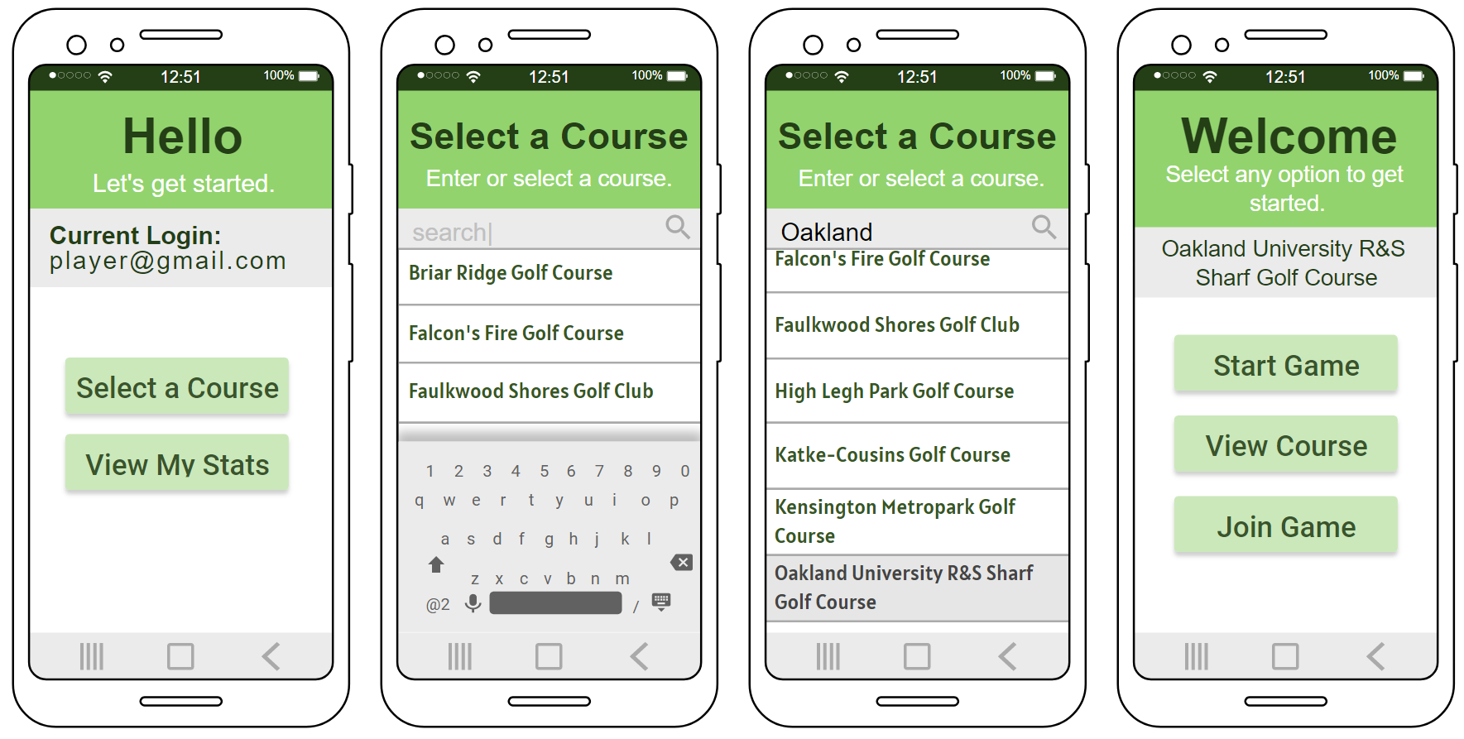

**Proposed Design #3:**

Primary color: #72bb53 to #457830 (Gradient)

To be used as backgrounds for headers and buttons.

Font color: #243e16

To be used for most text. When there is a block of green background with a header, use this. Use pure white for text below the header in the same block.

|  |
| --- |
| **This is a Header**  This is a description of what this page is. |
|
|  |

* All pages of the app should have a Header with a green gradient background at the top.
* All pages need a description of what they are for.
* Headers should not have periods.
* All sentences in a description should not have periods.
* Words on buttons/next to buttons should not have periods.
* Buttons should have bold, white text.
* Buttons should not have borders.
* Buttons should have gradients.
* Buttons should have a drop shadow.
* Buttons should be centered and fit in the middle of the screen.

